Playwright Locator
getByRole()
getByRole() finds elements by their ARIA role -> the accessibility role that tells screen readers what an element IS. A button is a button, an input is a textbox, a link is a link. These roles are built into HTML -> you don't need to add them manually.
﻿developer.mozilla.org/en-US/docs/Web/Accessibility/ARIA
aria-label
This is Playwright's #1 RECOMMENDED locator strategy. Why? Because ARIA roles are tied to WHAT the element IS, not how it looks. When the design team changes class="primary-btn" to class="main-button", the role button stays the same. Your test doesn't break.
<button role=button />
getByRole(role: "alert" | "alertdialog" | "application" | "article" | "banner" | "blockquote" | "button" | "caption" | "cell" | "checkbox" | "code" | "columnheader" | "combobox" | "complementary" | "contentinfo" | "definition" | "deletion" | "dialog" | "directory" | "document" | "emphasis" | "feed" | "figure" | "form" | "generic" | "grid" | "gridcell" | "group" | "heading" | "img" | "insertion" | "link" | "list" | "listbox" | "listitem" | "log" | "main" | "marquee" | "math" | "meter" | "menu" | "menubar" | "menuitem" | "menuitemcheckbox" | "menuitemradio" | "navigation" | "none" | "note" | "option" | "paragraph" | "presentation" | "progressbar" | "radio" | "radiogroup" | "region" | "row" | "rowgroup" | "rowheader" | "scrollbar" | "search" | "searchbox" | "separator" | "slider" | "spinbutton" | "status" | "strong" | "subscript" | "superscript" | "switch" | "tab" | "table" | "tablist" | "tabpanel" | "term" | "textbox" | "time" | "timer" | "toolbar" | "tooltip" | "tree" | "treegrid" | "treeitem", options?: {
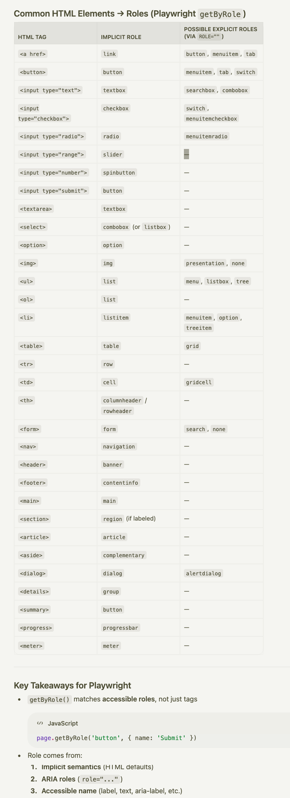
import { test, expect } from "@playwright/test";

test("find elements by ARIA role", async ({ page }) => {
await page.goto("https://app.com/login");

// Find heading
let heading = await page.getByRole("heading", { name: "Login" }).textContent();
console.log("Heading:", heading);

// Find textbox (input) by its label
await page.getByRole("textbox", { name: "Email" }).fill("dev@test.com");
console.log("Filled email textbox ✅");

// Find checkbox
await page.getByRole("checkbox", { name: "Remember me" }).check();
console.log("Checked 'Remember me' ✅");

// Find button
await page.getByRole("button", { name: "Sign In" }).click();
console.log("Clicked 'Sign In' button ✅");

// Find link
await page.getByRole("link", { name: "Forgot Password" }).click();
console.log("Clicked 'Forgot Password' link ✅");
});

Priority  +  +  + | Locator  + | Code Example  + | HTML Target  + | When to Use  +
1  + | getByRole | page.getByRole('button', { name: 'Submit' }) page.getByRole('heading', { level: 1 }) page.getByRole('checkbox', { checked: true }) | <button>Submit</button> | Best for accessibility. Works with ARIA roles. First choice always.
2  + | getByTestId | page.getByTestId('login-btn') page.getByTestId('user-card') | <button data-testid="login-btn"> | Most stable. Add custom test IDs for reliable automation.
3  + | getByText | page.getByText('Welcome back') page.getByText('Login', { exact: true }) page.getByText(/welcome/i) | <span>Welcome back</span> | Match visible text content. Supports regex.
4  + | getByLabel | page.getByLabel('Email') page.getByLabel('Password') | <label>Email <input/></label> | Form inputs with associated labels.
5  + | getByPlaceholder | page.getByPlaceholder('Enter email') page.getByPlaceholder(/search/i) | <input placeholder="Enter email"> | Inputs with placeholder text, no label available.
6  + | getByAltText | page.getByAltText('Company Logo') page.getByAltText(/profile/i) | <img alt="Company Logo"> | Images with alt text.
7  + | getByTitle | page.getByTitle('Close dialog') page.getByTitle(/settings/i) | <button title="Close dialog"> | Elements with title attribute.

